Gong Xian’s paintings were affected by “pragmatic studies” on universal and eternal scriptures

By Vincent LEE Kwun-leung
Art Officer
Art Of Nature International Company Limited

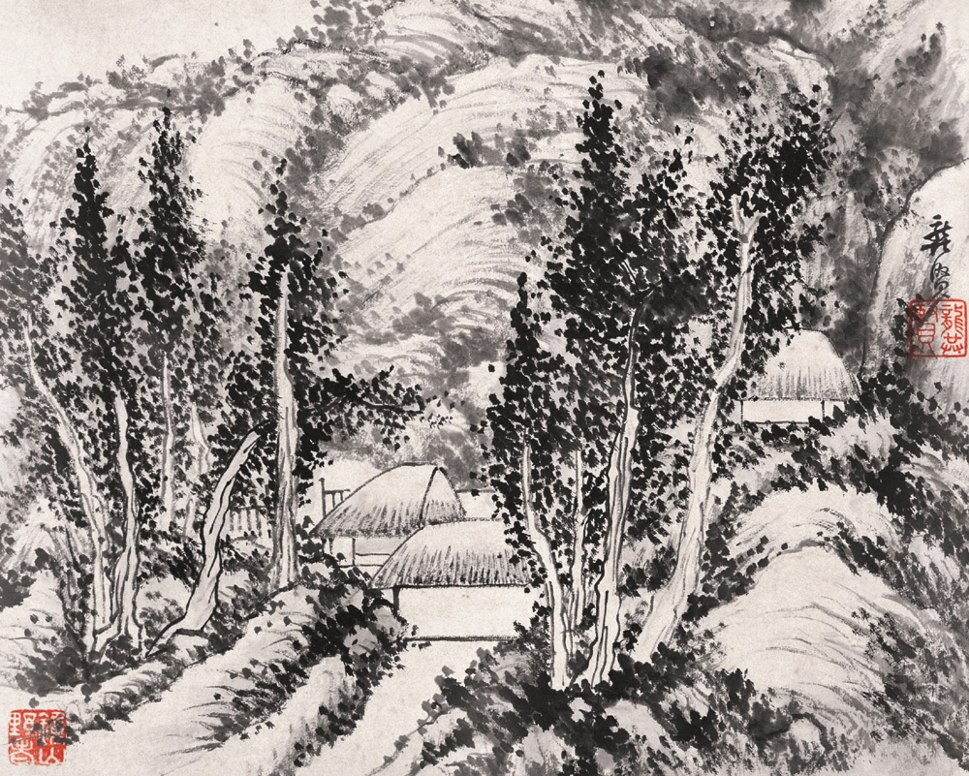

The landscape painting style of Gong Xian (龔賢 1619 – 1689) was well known with a naturalistic sense of freshness without stagnating visions. Also, judging from the “clearly defined” mountainous compositions and the “rationally patterned” ink accumulations (ji mo 積墨) of Gong Xian’s pieces, there was a reflection of organic mood without a departure from reality. Several Chinese art historians acknowledged Gong Xian’s attempt for a limited extent of modification on the trend of literati painting, which was securely fabricated by Dong Qichang, from an over-emphasis on randomness to a cautious investigation on contouring skills.

The reason for Gong Xian to present such a methodological uniqueness was that, his artistic experiences coincided with the political turbulence of Late Ming Dynasty. The reign of Emperor Shenzhong (明神宗) marked a turning point for the regular dynastic history of Chinese Civilization in the aspect of a slow-paced but eventual ideological connection with the entire world. On the one hand, Fr. Matteo Ricci and his missionary fellows paid a tributary visit to Beijing and broadened Emperor Shenzhong’s horizons with cultural and mechanical assets from European Civilization. On the other hand, the Ming Regime was initially trapped by the manoeuvring politics of “eunuch officials” and the increasing threats from Manchu barbarians. Gong Xian grew with a noble origin, but he could not prevent from re-positioning himself on the stance of Donglin Party and Fu Society while encountering the intransigence of eunuchs and corrupted bureaucrats in Ming Regime. His aspiration for a safeguard of intellectual righteousness and an unquestioned loyalty on the Ming governance explained why he persisted with “The School of Abandoned Intellectuals” (遺民派), instead of “The School of Legitimate Painting” (正統派), as his prior aesthetic approach. What Gong Xian cared the most was to penetrate the immortal secular thoughts within the bureaucratic personnel that counteracted with the corruptive influences and preserved the longevity of Ming governance.

A hint that is worth for us to make further analysis is that, the coming of Fr. Matteo Ricci in 1601 might indirectly contribute some inspirations to Gong Xian’s aesthetic breakthroughs. A researcher called Liu Gangji (劉綱紀) acknowledged a fact that, Gong Xian’s peers within the Donglin Party and Fu Society, such as Fan Fengyi (范風翼), Huang Mingli (黃明立) and Xue Gang (薛岡), cherished the “pragmatic studies on universal and eternal scriptures” (jing shi zhi xue zhi yong 經世致學之用) as their major ideological pursuit. According to the theories of Gu Yanwu (顧炎武), the cored values of “pragmatic studies” were to oppose emptiness in knowledge absorption, to bear the ideal of “problem-solving” and “salvation” while learning from the citation of articles and behaviours by ancient masters, to re-fabricate human sentiments, to overthrow injustices, and to bring wholesome affections to the community as a way of recruiting talented leaders for appropriate governance. Such tendency of ideological avocations were, as Chan Kai-wing (陳佳榮) commented in his publication called “A History Of The Communication Between China And Foreign Countries”, originated from the import of Western philosophies through the tributary visit of Fr. Matteo Ricci, for an encouragement on Chinese scholars during the reign of Emperor Shenzhong to begin an investigation on academic issues with innovative thoughts and methods.

Similar to the ideal of Fr. Francesco Sambiaso (1582 – 1649, a priest who accompanied Matteo Ricci’s tributary visit) in the aspect of issuing a publication called “A Forecast on Spiritual Languages” (Ling Yan Li Shao 《靈言蠡勺》), Gong Xian endeavoured with an exploration of “self-awareness” based on a persisting art practice. While making reference on the creative philosophies of Dong Qichang and the scholarly painters from either Song or Yuan Dynasty, Gong Xian respected ancient stylistic elements but alternatively transformed part of the corresponding innermost temperaments into an individualized manner of aesthetic representations. This reflected Gong Xian’s essential demands on the genuine quality of art, for his “precautious justification” on the pros and cons of relevant knowledge. In Gong Xian’s psychology, the idea of “succession” in the aspect of painting methodology was based on an inheritance of proper scholastic conduct. But, he insisted that such conduct was invisibly perceived. He was much influenced by the proclamation of Yan Yuan (顏元), that an enlightened scholar or a painter, with exceptional awareness on the peculiarity of moral values, no longer needed verbal reminders to comprehend the implications of virtues.

Fr. Matteo Ricci’s introduction of scientific and rational thinking to China, which paved the way for the popularity of “pragmatic studies on universal and eternal scriptures”, encouraged scholars in Donglin Party and Fu Society, including Gong Xian, to cherish the brave suspicions of Western culture and uphold the attitude of “liberation” while searching for precisions in his painting sophistication. According to the analysis of Liu Mo (劉墨), Gong Xian’s persistence on “The School of Abandoned Intellectuals” inevitably contributed avant-garde elements to a potential integration of “The School of Legitimate Painting” (正統派), headed by the Dong Qichang’s theories and represented by the Four “Wangs” in Early Qing Dynasty, with “The School of Wild Leisure” (野逸派), represented by The Eight Greatest Landscape Painters and Shi Shou (石濤). Such mixture was founded from the increasing maturity of “The School of Jinling” (金陵畫派), with Gong Xian as a great representative. According to the interpretation of Liu Mo (劉墨), the pursuit of Jinling style had sought an equilibrium between the court painting of Song Dynasty and the literati painting of Yuan Dynasty. While the Jinling paintings, like Gong Xian’s “The Hand-scroll Landscape with the Amber of Kapok Leafs” (《木葉丹黃圖軸》, Created in 1685, Size: 99.5 x 64.8 cm) were reflecting the preservation of structural aesthetic compositions with well-defined linear distributions and contrasting ink-chrominance, the pieces permit a transformation of one’s observed sceneries into leisurely brushstrokes with poetic illusions.

A statement from Gong Xian reflected how he cared for painters’ intellectual qualities to make influences on people’s aesthetic perceptions – “Once you comprehended virtues, you could be knowledgeably holistic. For sure, you can reserve yourself with minimal qualities because your reputation as a distinguished intellectual would not undergo any defects. If you disclosed your poets during your painting cultivation, all the emotions that you resorted to would reflect your persistence on virtues. This implied how you cared for the humanistic values. If you solely emphasized the manifestation of brushstrokes and ink, the pieces that you created were despicable…” [1] Gong Xian provided a framework that urged the literati painters in Ming Empire to cherish the reformative mission of Donglin Party and Fu Society – to inherit the righteous spirit of Chinese scholars in terms of caring for the national affairs and universal goodness. In the previous millenniums, the educated Chinese people only concentrated on the private interests or the matter of daily survival within their circuit of family members and relatives. To some extent, it was the tributary visit of Fr. Matteo Ricci that brought new inspirations to the liberal-minded officials who were annoyed with the preoccupation of anti-Donglin influences within the executive strata of Ming Court. Even though Gong Xian and his painter fellows with the same righteous aspiration might not engage in the party struggles too progressively, they attributed their hopes for ideological enlightenments and political stability to the changes in painting methodologies.

Fr. Jeannes de Rocha edited a catalogue called “A Brief Introduction on the Holy Statues of Lord” (天主聖像略說), and dedicated it to Emperor Shenzhong as a royal collection. This publication, being a source of proof, was predicted to have broadened the artistic horizon of particular literati painters like Gong Xian and Zhe Jiang (淅江), the founder of “The School of Xin’an Painting” (新安畫派). They initially comprehended the peculiarity of “human anatomy”, the coordination of “chrominance”, the logic of “luminance”, the accuracy of “observation” and the concept of “drawing”.

There was predicted to be a connection between the “Jinling” art pursuit of Gong Xian and the enlightenment of Western ideas. Through a Sino-Western comparative observation with epoch-based global events as a corresponding reference, it is thus worth for us to examine the inter-relationship between Fr. Jeannes de Rocha’s introduction of European painting culture, the philosophical contents of the emerging “pragmatic studies on universal and eternal scriptures”, and the ideological essences of Donglin Party and Fu Society with Gong Xian as its loyal member. Such inter-relationship helped us better justify that; the stylistic and technical changes of literati painting, with Gong Xian as a representative to set an example for a common emphasis between an imitation on tradition and a transformation on the innermost qualities of painting art; was a natural outcome for an alternation on Chinese aesthetics whenever the political unrest of Late Ming Regime coincided with the cultural penetration of the West.

[1] Original Chinese contents:
「明乎道，則博雅，亦可渾樸，亦可不失為第一流人。放詩文寫畫，皆道之緒余，所以見重於人群也。若淳之以筆墨為事，此之賤也。」

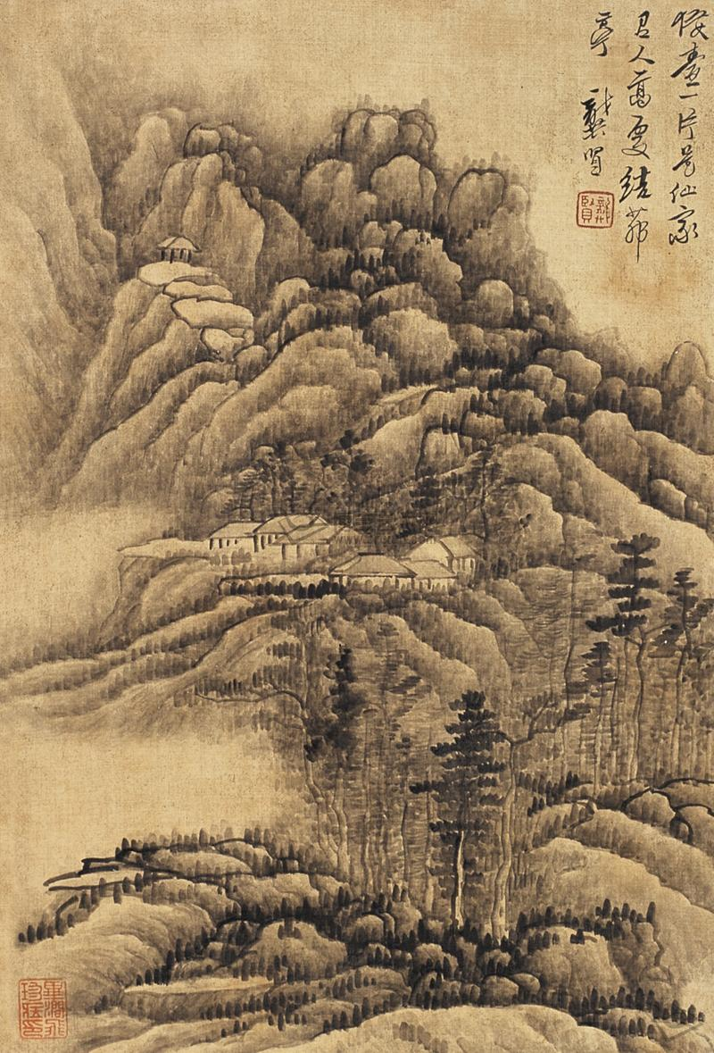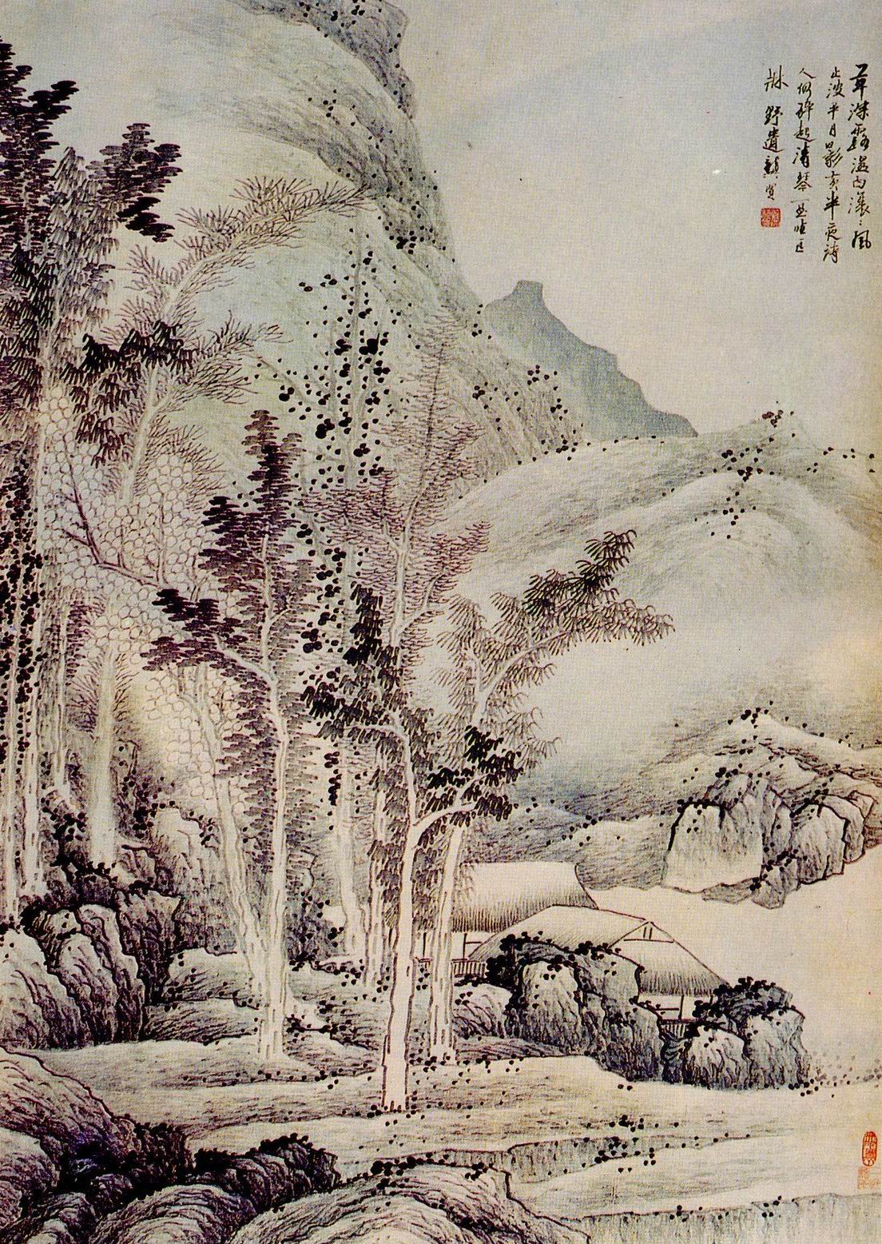

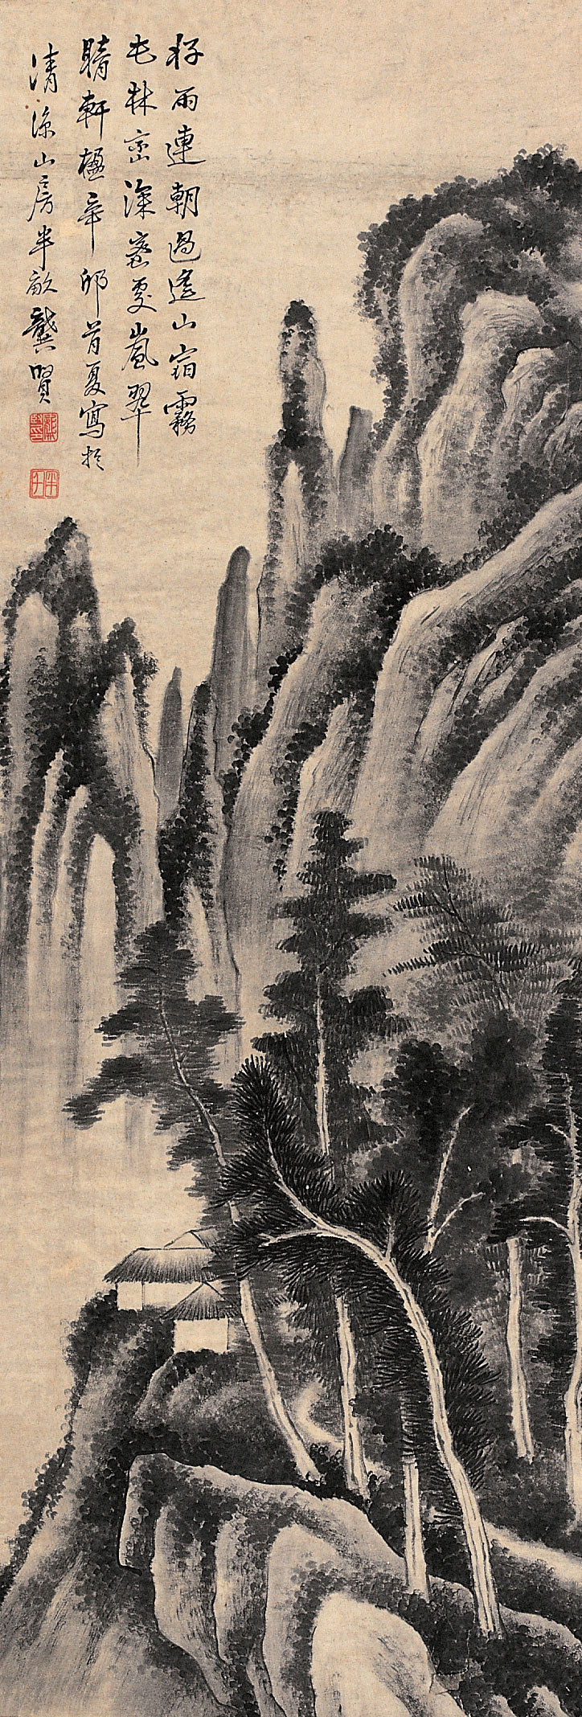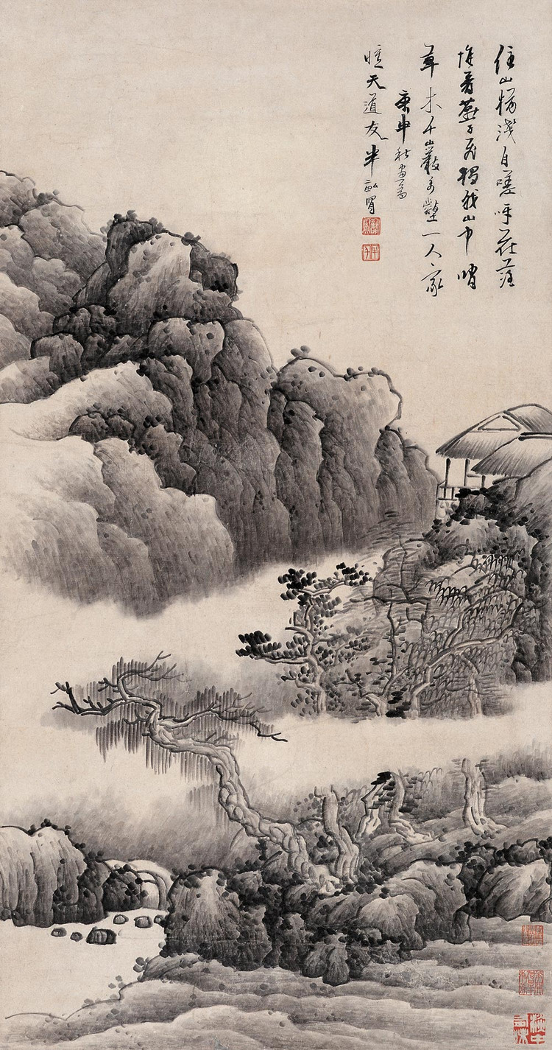

SOURCES OF ARTWORK PHOTOS:

Fang, Wen C. “Images of The Mind: Selections from The Edward L. Elliott Family and John B. Elliott Collections of Chinese Calligraphy and Painting at The Art Museum, Princeton University”, Princeton: Art Museum, Princeton University in association with Princeton University Press, 1984.

Cahill, James. “The Compelling Image: Nature and Style in Seventeenth Century Chinese Painting”, Cambridge, Mass.: Harvard University Press, 1982.

Jonathan D. Spence, “The Memory Palace of Matteo Ricci”, Shanghai, Shanghai Yuandong Publishing Company Limited, 2005

John D. Young, “East-West Synthesis: Matteo Ricci and Confucianism”, Hong Kong, Centre of Asian Studies, University of Hong Kong, 1980

Joseph Sebes, “A Bridge Between East And West: Father Matteo Ricci S.J., his time, his life, and his method of cultural accommodation”, Taipei, I.S.C.W.C.I, 1983

