The theory of self-nourishment by Shi Tao
The wild leisure of Shi Tao’s aesthetics contributed enlightened elements to the development of Rococo and Impressionism under the growing trend of “Chinoiserie” in Western world

By Vincent LEE Kwun-leung
Art Officer, Art Of Nature International Company Limited

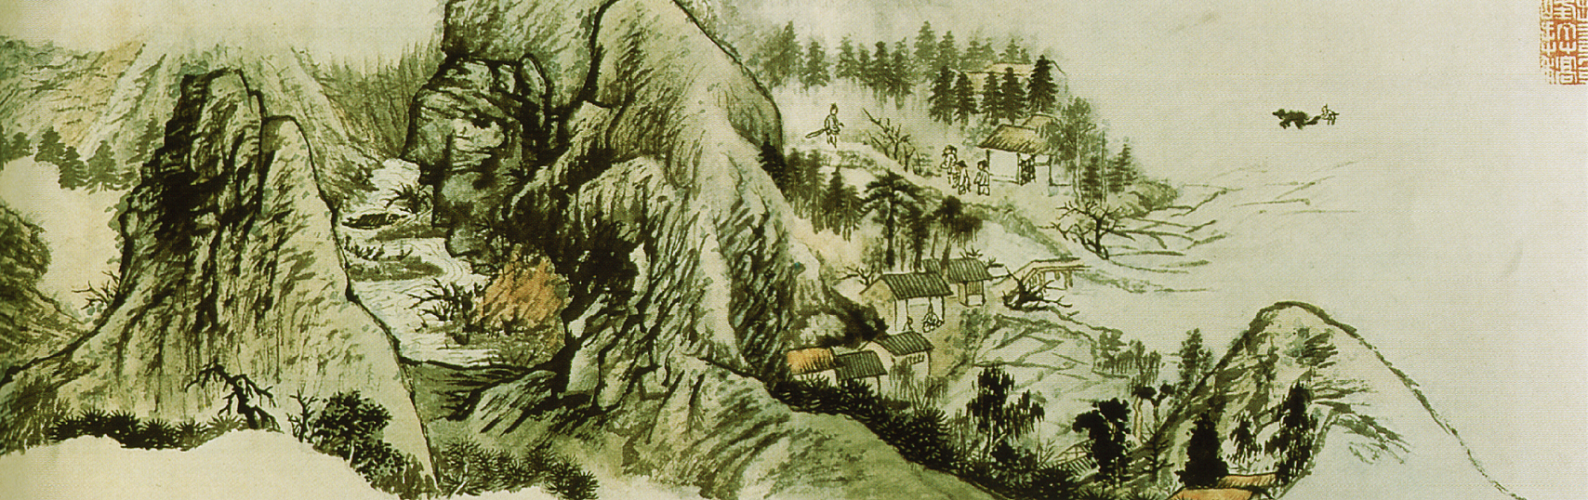
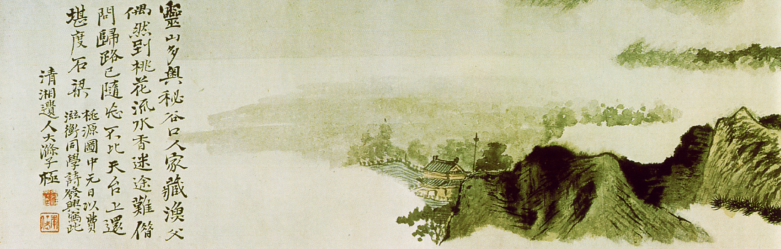

Based on a comprehension on the ultimate idea of “regularities” (fa 法), Shi Tao (1642 – 1665) advocated that painters should cultivate legitimate aesthetic virtues themselves with a psychology of ignorance and tranquility. Such emphasis on a transcendence of innermost perception was attributed to the trend of academic pursuit in Late Ming and Early Qing Dynasty, which the essential reflection of inspirations originated from an emphasis on the subconscious expression of subjective emotions and consciousness. Shi Tao situated in an epoch which Emperor Kang Xi implemented the promotion of Buddhism, Zhu Xi’s virtue-based philosophies, and the academic theories by Cheng Yi and Cheng Hao as a sort of “moderate policy” for a better racial assimilation between Manchu and Han Chinese.

Emperor Kang Xi was able to manifest the prosperous expansion of academic system, namely “liberal studies for a recruitment of talented Confucian scholars” (bo xue hong yu 博學鴻儒) to achieve a status of national stabilization. He was not wholehearted with the ultimate knowledge of Buddhism, but he made it as a kind of expediency to re-modify Ming literati, including Shi Tao, from having repulsive feelings upon the Manchu governance. As Emperor Kang Xi brought about socio-economic prosperity in China, many European intellectuals admired to study how the Qing Government could guarantee citizens with proper livelihood and well academic qualities. Being eager to reform Europe from the political status of autocracy and religious superstitions, Gottfried Wilhelm Leibniz and Claudia Filippo Grimaldi, from Ignatus of Loyola, made a tributary visit to Qing Regime and brought the Chinese scriptural materials back to Europe in 1689. Joachim Bouvet edited a publication called “Novissima Sinica” to urge for a reformation of moral values in Europe by making reference on the enlightened rule of Emperor Kang Xi. Yet, it was believed that, once Shi Tao was absorbed by Qing Regime to persist with his established painting approaches, i.e. The School of Wild Leisure, his style contributed a particular extent of influence to the Chinese-art awareness of the aforementioned missionaries. The loosened pigments of Rococo painting art were inspired by the self-expressiveness of Chinese aesthetics, which stressed a transformation of established training style through a release of spiritual leisure in return for a mature development of individual art formats.

The painting style of Shi Tao and the post-Renaissance art in Europe were supposed of sharing some similarities in the aspect of emphasizing a reflection of soul from heart, which corresponded to Emperor Kang Xi’s implementation of “virtue-based philosophy”. Zhu Xi claimed that, “Moderation (zhong he, 中和) came from our force, and no boundary existed between Heaven and humans. The allocation of Heaven and Earth, and the nurture of creatures, continuously persisted with our wholesome initiation. These two pairs of persistence were a representation of mutual-dependence, mutual-supplementation and mutual-assistance. If moderation could not be achieved, there would be a mutual-exhaustion between mountains and rivers, as well as instability of Heaven and Earth. The emergence of infant mortality was due to such kind of ruined harmony.” The idea of “moderation” stressed that a maintenance of equilibrium helped mankind achieve a harmonious coexistence with the nature, as the existing values and interests of each side were re-considered. Both human and nature were tolerated to preserve their unique characteristics and obtain a normal platform of development. Missionaries from Ignatus of Loyola respected the ecological ethics, as they believed that Confucian worship in China never confronted with the Catholic values. They published a scripture called “Sinarum Scientia Politics” (中庸) to justify such ecological perception. According to Xuan Shichang (孫世昌)’s interpretation, Shi Tao used to search for moderation among heart, substances, virtues and sentiments. In Shi Tao’s mind, these elements belonged to the category of “breath” (qi 氣), which had to be attained by a preservation of innermost solemnity during a cultivation of loosened but leisurely mountainous structures.

The theory of “self-nourishment” (meng yang zhi dao 蒙養之道), proclaimed by Shi Tao, was similar to Zhu Xi’s emphasis on self-cultivation – a prior step of appropriate management on spiritual temperaments as a way towards the realm of universal awareness. To acquire self-nourishments, what a landscape painter, like Shi Tao, needed to tackle with was to coordinate his mentality with the regularities of nature. The transformation of natural substances as aesthetic expression depended on one’s consciousness on the random penetration of Chinese ink, which required the author to possess a consistent sensitivity on the peculiar features and the internal spiritual essences of landscapes. From Shi Tao’s notable piece called “Coexistence Between Painting & Calligraphy – The Twelve Version of Precious Collection” (《書畫合壁冊》之十二), vagueness were reserved from the relaxing approach of textural strokes. The clear contrast between the light foggy layer and the condensed rocky patterns was presented as a demonstration of unity among theories, virtues and regularities. This unity was named as “one particularly dominant stroke” (yi hua 一畫) – a sophisticated level of contouring practice by a connection with Heavenly spirits without hesitation, and it helped a painter like Shi Tao to manifest the merges and changes from the swirl of “yin” and the circulation of “yang”. Gottfried Wilhelm Leibniz might foster a certain sense of understanding while observing the contrasting monochrome from Shi Tao and his artistic peers’ approach of ink application with varying portion of moistures. Leibniz’s contribution in the aspect of applying the “yin-yang” concept in the Catholic interpretation of Heavenly connection is foreseen as stimulating a change of Europeans’ perspective on the nature of oil-painting chrominance. French painters, like Monet, began to adore a general description of one’s “impression” upon a particular episode, instead of pursuing a detailed contouring technique to express the concreted textures.

Shi Tao’s approach of “self-nourishments” comprised the maintenance of wholesome moral conditions, which corresponded to the eagerness of Francois Quesnay in the aspect of upholding kindness as an invisible guarantee for hierarchical stability. Sharing the same belief with Gottfried Wilhelm Leibniz, Shi Tao denied an over-emphasis on utilitarian thoughts. To the artistic philosophy of Shi Tao, the comprehension on natural regularities helped painters to adore the purity of aesthetics. As Xuan Shichang explained, the method of perceiving “regularities” was to foster a high level of mental concentration, command the overall aesthetic distribution with sophistication on major items, and extend the spiritual realm to the entire painting surface with a sensitivity on the essence of ink penetration. For Gottfried Wilhelm Leibniz and his missionary fellows, he believed that “regularities” provided framework for Europe to carry on environmental conservation and agricultural learning despite the rapid growth of industrial economy and the emerging system of commercial monopolization. He encouraged the European intellectuals, like John Hay, to admire the aesthetic elements of Chinese treasures, like porcelains, lacquer art, vases, landscapes and temples. This enabled Chinese art to play an “ambassador-liked” role to push forward a trend of aesthetic transformation in Europe, which was reflected from the formation of French enamelware in the 18th century, the emergence of Baroque art trend, and the “Rococo” painting visions. Amongst, French Impressionism, led by Monet, Manet and Paul Cézanne, corresponded to the “School of Wild Leisure” represented by Shi Tao based on a reflection of distilled illusions from artists’ eyeballs, despite the episodes were of vague chrominance and contours.

To conclude, it is advised to draw a closer look at an invisible mutual affection between Shi Tao’s art styles and the corresponding Western art trends beyond the occurrence of Renaissance. The coming of missionaries from Ignatus of Loyola to Beijing during the reign of Emperor Kang Xi provided a hint for me to observe how Shi Tao contributed to the “Chinoiserie” in Europe in the aspect of renewed universal perceptions in the nature of art creativity.

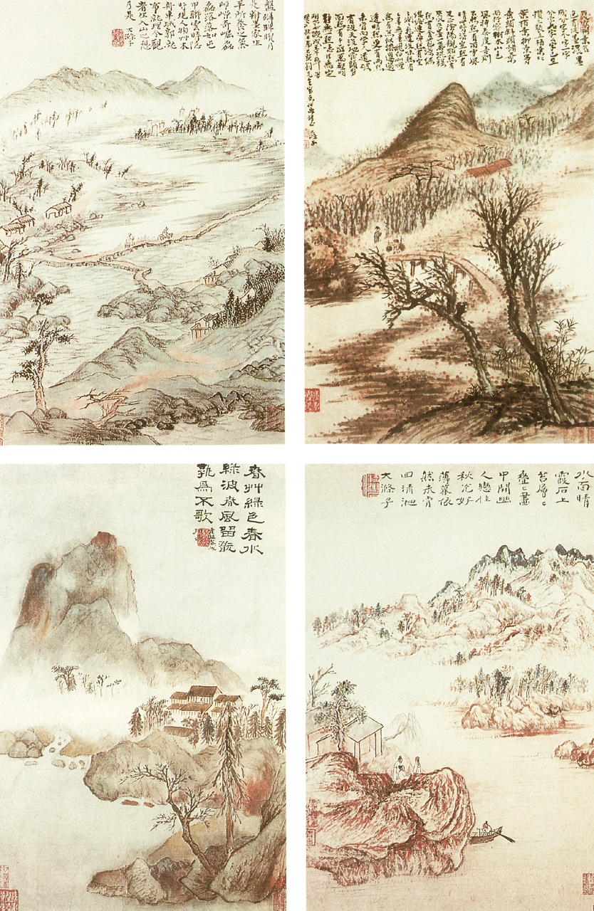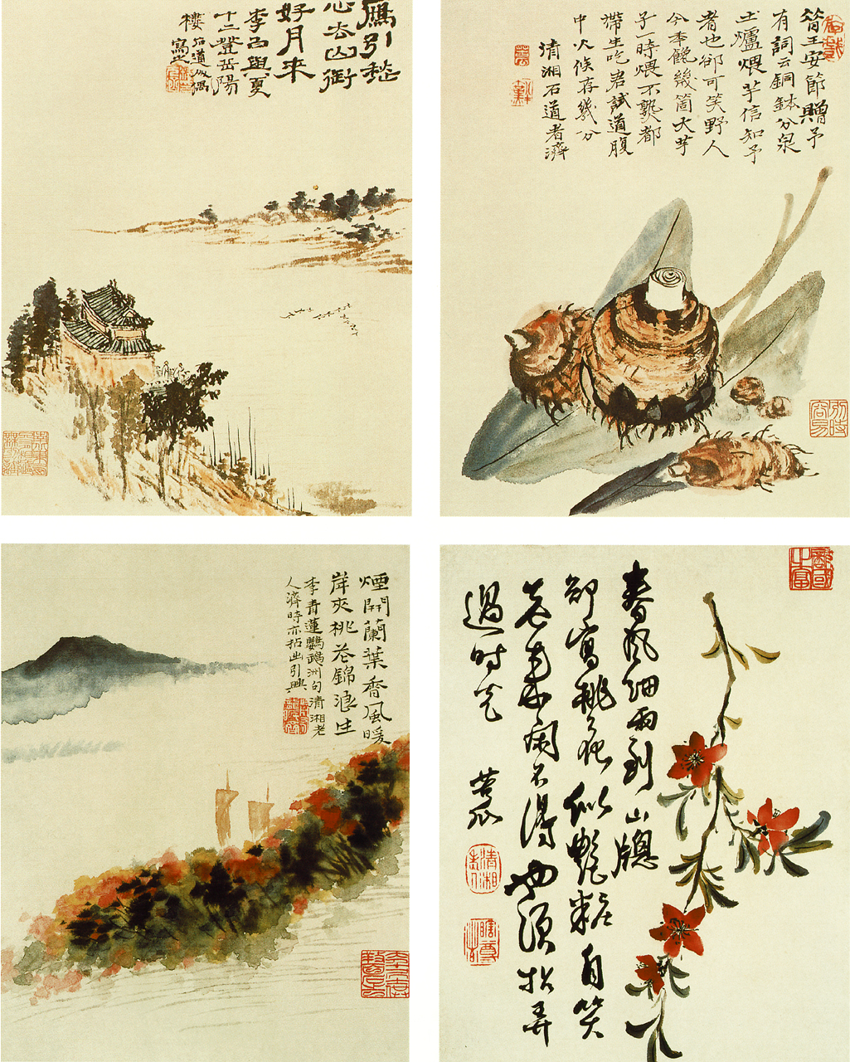
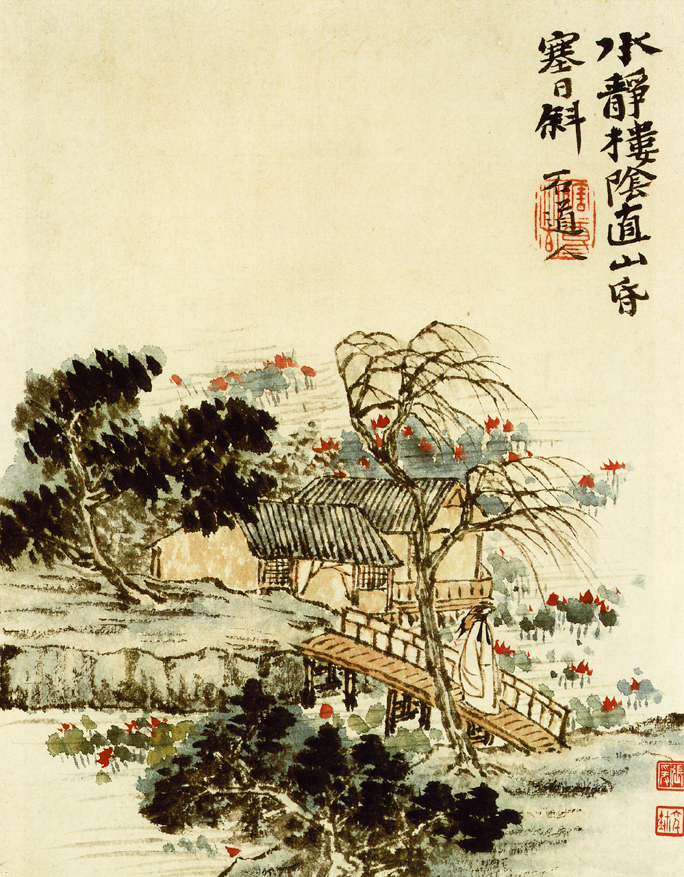
PROPOSED BIBLIOGRAPHICAL REFERENCES

Scholastic Publications
- 牛繼飛：《石濤》。太原市：山西教育出版社，2006。
- 楊成寅：《石濤》。北京：中國人民大學出版社，2003。
- 《石濤研究》。上海：上海書畫出版社，2002。
- 《十七世紀至十八世紀．石濤》。北京：人民美術出版社，2002。
- 韓林德著：《石濤評傳》。南京：南京大學出版社，1998。
- 韓林德著：《石濤與〔畫語錄〕研究》。江蘇：江蘇美術出版社，1989。
- 戴海鷹著：《石濤．磊阿不群的清初畫僧》。
- 鄭拙廬著：《石濤研究》。香港：中華書局，1977。
- 孫世昌著：《石濤藝術世界》。遼寧：遼寧美術出版社，2002。
- 匡亞明編，韓林德著：《中國思想家評傳叢書．石濤評傳》。南京：南京大學出版社，1998。
- 丁家桐著：《石濤傳》。上海：世紀出版集團，2000。
- 俞劍華著：《國畫研究》。桂林：廣西師範大學出版社，2005。
- 曹玉林：《王原祈與石濤：清初山水畫壇的正奇兩極》。上海市：上海書畫出版社，2004。
- 王宏印：《畫語錄注譯與石濤畫論研究》。北京市：北京圖書出版社，2007。
- 孫小禮：《萊布尼茨與中國文化》。北京：首都師範大學出版社，2006。
- George MacDonald Ross：《萊布尼茨》。北京：中國社會科學出版社，1987。
- Ruth Lydin Saw：《萊布尼茲》。臺北：長橋出版社，民國67年（1978）。
- 《萊布尼茨和中國》。福州：福建人民出版社，1993。
- 劉海翔：《歐洲大地的中國風．Chinoiserie》。深圳市：海天出版社，2005。
- Claudia von Collani著，李岩譯，張西平、雷立柏審校：《耶穌會士白晉的生平與著作》（P. Joachim Bouvet S.J: sein Leben und sein Werk）。鄭州市：大象出版社，2009。
- 白晉：《康熙皇帝》。哈爾濱：黑龍江人民出版社，1981。
- Francois Quesnay (1694 – 1774)：《中國帝國的專制制度》。北京：商務印書館，1992
- 蔡方鹿、舒大剛、郭齊主編，尹波副主編：《新視野，新詮釋．朱熹思想與現代社會》（Vol. 1 & 2）。成都市：四川大學出版社，2007。
- Freiherr von Gottfried Wilhelm Leibniz (1646 – 1716) as author; translated with an introduction, notes, and commentary by Jr. Henry Rosemont and Daniel J. Cook, “Discourse on the Natural Theology of the Chinese”, Honolulu, University Press of Hawaii, 1977
- Freiherr von Gottfried Wilhelm Leibniz (1646 – 1716), “Writing on China”, Ill Chicago, Open Court, 1994
- Oliver R. Impey, “Chinoiserie: The Impact of Oriental Styles on Western Art and Decoration”, London, Oxford University Press, 1977
- Michael Levey, “Rococo to Revolution: Major Trends in Eighteenth-Century Painting”, London, Thames & Hudson, 1966
- Terisio Pignatti (1920 – 2004), “The Age of Rococo”, London & New York, Hamlyn, c1969
- Vemon Hyde Minor, “Baroque & Rococo: Art & Culture”, New York, Harry N. Abrams, 1999
- Germain Bazin, “Baroque and Rococo”, London, Thames & Hudson, 1964
- Lewis A. Maverick (1891 – ), “China, a model for Europe”, San Antonio Tex., Paul Anderson, c1946

Catalogues
- 中國古代書畫鑒定組編：《中國古代書畫圖目》，第一至二十二冊。北京：文物出版社，1986。
- 中國古代書畫鑒定組編：《中國繪畫全集》。杭州：浙江人民美術出版社，北京：文物出版社，1997-2000。
- 中國美術全集編輯委員會編：《中國美術全集》。北京：文物出版社，上海：上海人民美術出版社，天津：天津人民美術出版社，1988-1997。
- 責任編輯于瀛波：《17世紀至18世紀．石濤畫語錄譯解》。北京：朝花美術，1963。
- 責任編輯王之海：《石濤書畫全集》。天津：天津人民出版社，1995。
- 蕭燕翼：《故宮藏石濤繪畫》。北京：紫禁城出版社，2002。
- 《四僧畫集：髡殘、石濤、淅江、八大山人》。北京市：中國民族攝影藝術出版社，2003。

Others
1. 《耶穌會羅馬檔案館明清天主教文獻》。臺北市：利氏學社，2002。

